LAB 9: Wireless Network Setup and Packet Analysis using Cisco Packet Tracer
OBJECTIVES:
- To set up a wireless router and build a wireless network environment within Cisco Packet Tracer.
- To link wireless end devices to the network and distribute IP addresses through a DHCP server.
- To confirm protected wireless communication by implementing WPA2 security parameters.

THEORY:
A wireless network enables devices to exchange data without requiring physical cables by transmitting signals through radio frequency waves. In this experiment, a wireless router is set up to build a WLAN that delivers connectivity, automatic IP allocation via DHCP, and controlled access for wireless clients. The router handles address distribution to all connected devices, promoting smooth and organized network operation.
The SSID serves as a unique label for identifying the wireless network, while WPA2 security paired with AES encryption guards against unauthorized users by requiring a valid passphrase to gain entry. Wireless clients join the network by providing the correct SSID and credentials, after which data transfer can be confirmed through connectivity tests.
Packet analysis enables users to monitor and interpret how data travels between wireless devices and the router. Through the simulation mode and packet inspection capabilities in Cisco Packet Tracer, various packet types — including DHCP, ARP, and standard data packets — can be examined in detail. This examination clarifies how devices acquire IP addresses, form connections, and send information across the wireless medium. It also supports the validation of successful communication and aids in diagnosing network faults, making it a core element of any wireless network deployment.

Network Topology:
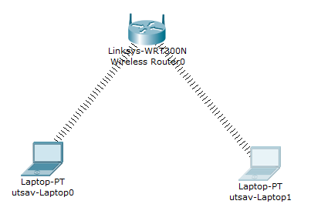

PROCEDURE:
Wireless Router Configuration:
Step 1: Basic Setup
- Click on the Wireless Router.
- Navigate to GUI → Setup.
- Enter the following settings:
  - IP Address: 192.168.0.1
  - Subnet Mask: 255.255.255.0
  - DHCP Server: Enabled
Step 2: Wireless Configuration
- Navigate to Wireless → Basic Wireless Settings.
- Apply the following parameters:
  - Network Mode: Mixed
  - SSID: HCOE
  - Channel: Auto
- Click Save Settings.
Step 3: Wireless Security
- Navigate to Wireless → Wireless Security.
- Enter the following details:
  - Security Mode: WPA2-Personal
  - Encryption: AES
  - Passphrase: hcoe@123
- Save the configuration.

OBSERVATION:
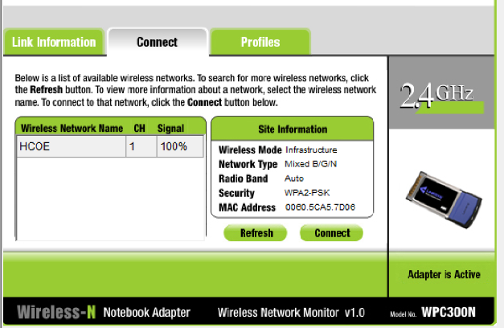

RESULT:
The configuration successfully created a fully operational wireless network using a WRT300N router. With the SSID set to "HCOE" and the DHCP server activated at the gateway address 192.168.0.1, the network was prepared to accept client connections. Both Laptop0 and Laptop1 detected the wireless signal at 100% strength and completed authentication using the WPA2-PSK passphrase "hcoe@123". Final outcome, both laptops were dynamically assigned IP addresses and were able to transmit data packets through the router without issue.

DISCUSSION:
This experiment illustrates how DHCP and WPA2 security complement each other in building a practical and protected wireless environment. By activating the DHCP server, the router took over the responsibility of assigning addresses to both laptops automatically — a process that is considerably more efficient and less error-prone than manual configuration. Applying WPA2-Personal security with AES encryption was arguably the most essential step in the setup, as it restricts access to the network by requiring users to provide a valid passphrase before connecting.
CONCLUSION:
This lab effectively demonstrated that a secure and fully functional wireless network can be built by properly configuring the SSID, WPA2 security protocol, and DHCP services on a wireless router.

